College & Career Advising  Program Domains | Grade 9 | Grade 10 | Grade 11 | Grade 12
Personal Social Skills | - Naviance: Learning Style Inventory  - Advisory: Barr curriculum  - Becoming a Man Program (BAM)  - | - Naviance: Complete Strengths Explorer assessment  - Advisory Curriculum  - BAM | - Naviance: Do What You Are Assessment  - Advisory Curriculum  - Defense of Learning | - Naviance: Complete the BPS Senior Exit Survey in Naviance Student  - Advisory Curriculum  - Essay for college application
Career Awareness | - Naviance: Complete Career Cluster Finder (CCF) assessment  - Begin building resume | - Naviance: Build/update resume | - Career Panels/Guest Speakers  - Naviance: Upload Resume | - Career Panels/Guest Speakers  - Naviance: Upload Resume
Career Exploration | - Through quarter long pathway classes | -- Write Career Research paper  - Yearlong elective in Pathways choice  Use online tool to explore two careers of interest  - Job Shadow  - Site Visits | - Job Shadow  - Site visits  - Career Research Paper in class  - Performance Assessments | - Job Shadow  - Site Visits  - Performance Assessments and final project
Career Immersion |  | - Optional Internships | - Internships (Pathway aligned)  - Harvard Med Science | - Internships (Pathway Aligned)  - Harvard Med Science
Academic Advising | - Naviancereate 1 Academic SMART Goal for 9th Grade  -Workshops on Graduation Requirements and College expectations  - Grade review and intervention for failing students using early warning indicators | - Naviance: Create 1 Academic SMART Goal for 10th Grade  - Workshops on Graduation Requirements and College expectations  - Grade review and intervention for failing students using early warning indicators | -Naviance: Create 1 Academic SMART Goal for Senior Year Transition  - Naviance: Link College Board and Khan Academy accounts  Meet with students for credit review to ensure ontime graduation  - Grade review and intervention for failing students using early warning indicators  -tutoring for Early College/Dual Enrollment | - Final grade audit for graduation  - Grade review and intervention for failing students using early warning indicators  - tutoring for Early College/Dual Enrollment
College and Career Planning | - Naviance: Complete Roadtrip Nation (RTN) activity & Reflection Survey  - Naviance: re-Survey for October 26, 2019 City-wide College & Career Fair  -Advisory curriculum Naviance Introduction  - College Fair  - College Visits  - Pathway exploration | - Naviance: Dual Enrollment Survey  - Naviance: Pre-Survey for October 26, 2019 City-wide College & Career Fair  - Naviance: Complete Roadtrip Nation (RTN) activity & Reflection Survey  - Advisory curriculum  - College Fair  - College Visit  - Naviance Supermatch  - PSAT  - CS Pathway Wentworth Visit and Lab activity | - Naviance: Students complete Super Match College Search and add at least one college of interest to their “Colleges I’m Thinking About” list  -Naviance: Complete Roadtrip Nation (RTN) activity & Reflection Survey  - College Fair  - College Visit  - Naviance - supermatch  - Early College/Dual Enrollment  - Early College Bootcamp  - Dual Enrollment Family Engagement Night @ Wentworth  - Year Up and Alternative Pathway visits  - PSAT  - In school SAT | - Naviance: Apply to college  - Register for Opportunity Scholarship  - Search for Scholarships  - Naviance: Update “College I’m Attending”  College Fair  - College Visit  - Early College/Dual Enrollment  - Early College Bootcamp  - Dual Enrollment Family Engagement Night @ Wentworth  - College Essays  - Year Up and Alternative Pathway visits  - UASPIRE/FAFSA
Pathway Specific College Awareness | All 9th graders have 1-2 experiences at the Wentworth Campus including at tour, lunch and an interactive lab (robotics) with Wentworth faculty to build familiarity with the institution | All 10th graders will receive  Semester 1: College Readiness workshops embedded in their year long pathway electives at least monthly  Semester 2: There will be on campus workshops in the students elective area to have student engage in hands on learning in labs but also replicating labs that will be done in each of their classes of choice  (students who feel academically ready may start MATH1000 in the spring) | All 11th graders in the pathway will be able to choose a complementary early college pathway to their pathway of choice in Engineering, Computer Science or Math | All 12th graders will be offered the opportunity to continue in their Early College pathway or the ability to take other Early College or Dual Enrollment classes based on their chosen pathway or individual reflections and post secondary planning.

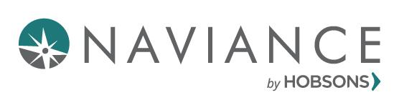 CCLR Scope & Sequence (SY 19-20) 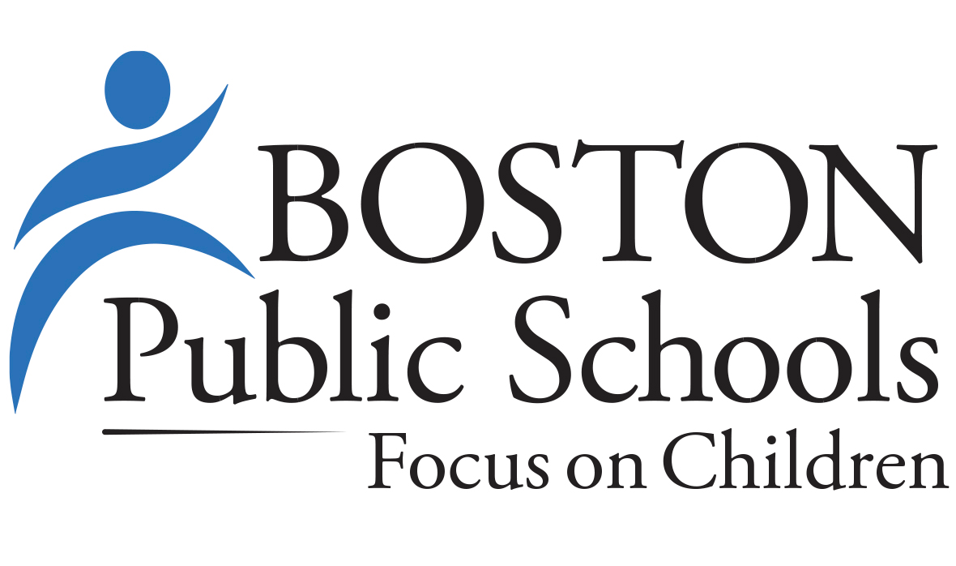
Boston Public Schools

District Vision
The BPS vision is all students will be prepared with the knowledge, skill, and character to excel in college, career, and life. We are confident that a thoughtful, strategic implementation of Naviance within BPS will assist the district in making gains towards its vision and its strategic goals. For this first year of implementation, the focus will be on aligning Naviance activities to the Massachusetts definition of college and career readiness and reporting on key metrics that move the needle on college and career readiness within BPS.

2019-2020 BPS Responsibilities
District/Central Office Responsibilities:
- Continue to schedule and provide professional development to staff to support the District’s Naviance implementation and professional development plan
- Continue to monitor the number of staff trained and objectives accomplished
- Participate in meetings with the Naviance team to continually monitor progress on outlined goals and determine strategies to mitigate any challenges as they arise
- Create and administer the Class of 2020 graduation survey via Naviance in order to show outcomes for current seniors
School Level Responsibilities:
- Schools will fully incorporate Naviance into their counseling programs and utilize Naviance tools to monitor and track student progress towards college & career readiness.

Resources:
BPS MyCAP Plan
BPS Scope and Sequence Manual https://drive.google.com/open?id=1fml5KjJpc9psbPA3yr9Nq0-eXHNBcibZ
CCLR Framework: https://www.naviance.com/content/cclr-framework
MMFW Curriculumhttps://drive.google.com/drive/u/1/folders/0AIJXxmQBkEuMUk9PVA

Naviance Framework by Grade Level
9th Grade
Naviance Activity | Completion Trigger in Naviance | CCLR Framework Alignment | MyCAP - MMFW & Signaling Success Curriculum Modules | Timeline | Responsible Party
Create 1 Academic SMART Goal for 9th Grade | Student adds SMART goal in the “9th Grade Academic” category | 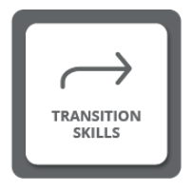 | Module 2-Career Exploration, Planning, and Postsecondary Pathways  Personal Roadmap pg. 131  ELA Academic Content Standards | October  2019 | Core Content Teachers; School Counselors
Pre-Survey for October 26, 2019 City-wide College & Career Fair | Student completes a custom College & Career Fair survey in Naviance about the exhibitors who will attend |  | Module 2-Career Exploration, Planning, and Postsecondary Pathways  Coat of Arms pg. 91  Module 4-College Entry, Survival and Success  Dodge the Pitfalls-pg. 409 | October  2019 | CTE Teachers; CAC Advisers; School Counselors
Learning Style Inventory | Student completes the Learning Style Inventory assessment | 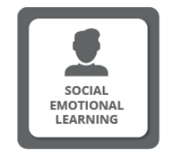 | Module 1-Exploring Self and Identity  Myers-Briggs Type-pg. 103  Module 2-Career Exploration, Planning, and Postsecondary Pathways  Work Personality-Finding Your Match pg. 143 | February  2020 | Core Content Teachers
Complete Career Cluster Finder (CCF) assessment | Student completes Career Cluster Finder assessment | 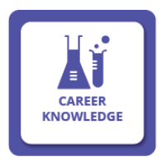 | Module 2-Career Exploration, Planning, and Postsecondary Pathways  World of Work Research Project pg. 163  Module 3-My 21st Century Toolkit  Resources and Barriers pg. 283 | December  2019 | CTE Teachers; School Counselors; CAC Advisers
Complete Roadtrip Nation (RTN) activity & Reflection Survey | Student completes custom RTN Reflection Survey | 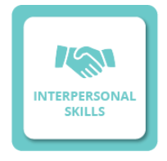 | Module 1-Exploring Self and Identity  Personal Roadmap pg. 131  Module 2-Career Exploration, Planning, and Postsecondary Pathways  World of Work Research Project pg. 163  Module 3-My 21st Century Toolkit  Different Pay for Different People pg. 287 | December  2019 | CTE Teachers; School Counselors; CAC Advisers
Begin building resume | Student creates a new “print format” of their resume |  | Module 1-Exploring Self and Identity  Who Am I? pg.77  Module 2-Career Exploration, Planning, and Postsecondary Pathways  World of Work Research Project pg. 163  Module 3-My 21st Century Toolkit  Mock Interviews pg. 301, Collaborative Resume Writing pg. 307, ELA Academic Content Standards | May  2020 | School Counselors; English Teachers

10th Grade
Naviance Activity | Completion Trigger in Naviance | CCLR Framework Alignment | MyCAP - MMFW & Signaling Success Curriculum Modules | Timeline | Responsible Party
Create 1 Academic SMART Goal for 10th Grade | Student adds SMART goal in the “10th Grade Academic” category |  | Module 2-Career Exploration, Planning, and Postsecondary Pathways  Zeteophobia pg. 296  Personal Roadmap pg. 131  ELA Academic Content Standards | November  2019 | Core Content Teachers; School Counselors; CAC Advisers
Dual Enrollment Survey | Student completes Dual Enrollment survey answering questions about which colleges are available for dual enrollment, which course is of interest, etc. |  | Module 2-Career Exploration, Planning, and Postsecondary Pathways  Self-Directed Search pg. 148  Module 4-College Entry, Survival and Success  Dodge the Pitfalls pg. 409 | December  2019 | School Counselors;  CAC Advisers
Pre-Survey for October 26, 2019 City-wide College & Career Fair | Student completes a custom College & Career Fair survey in Naviance |  | Module 2-Career Exploration, Planning, and Postsecondary Pathways  Alternatives to a 4-year College pg. 254  Going to College-Is it for Me? Pg. 213  Module 4-College Entry, Survival and Success  What do Colleges Expect? Pg. 449 | October  2019 | School Counselors;  CAC Advisers
Complete StrengthsExplorer assessment | Student completes StrengthsExplorer assessment and identify their emerging talents |  | Module 1-Exploring Self and Identity  The Five Things pg. 98  Module 2-Career Exploration, Planning, and Postsecondary Pathways  Work: Love It or Hate It pg. 195 | April  2020 | Core Content Teachers; School Counselors; CAC Advisers
Complete Roadtrip Nation (RTN) activity & Reflection Survey | Student completes custom RTN Reflection Survey |  | Module 1-Exploring Self and Identity  Personal Roadmap pg. 131  Module 2-Career Exploration, Planning, and Postsecondary Pathways  World of Work Research Project pg. 163  Module 3-My 21st Century Toolkit  Different Pay for Different People pg. 287 | April  2020 | School Counselor; PIC Career Specialist; CAC Advisers
Build/update resume | Student creates a new “print format” of their resume |  | Module - Exploring Self and Identity  Who Am I? pg.77  Module 2-Career Exploration, Planning, and Postsecondary Pathways  World of Work Research Project pg. 163  Module 3-My 21st Century Toolkit  Mock Interviews pg. 301, Collaborative Resume Writing pg. 307, ELA Academic Content Standards | March  2020 | School Counselor; PIC Career Specialist

11th Grade
Naviance Activity | Completion Trigger in Naviance | CCLR Framework Alignment | MyCAP - MMFW & Signaling Success Curriculum Modules | Timeline | Responsible Party
Link College Board and Khan Academy accounts | Student marks the task “complete” in Naviance Student |  | Module 1-Exploring Self and Identity  Personal Roadmap pg. 131  Module 4-College Entry, Survival and Success  Dodge the Pitfalls pg. 409 | December  2019 | CAC Advisers  School Counselors
Do What You Are Assessment | Student completes the Do What You Are assessment for Myers Briggs results |  | Module 1-Exploring Self and Identity  Myers-Briggs Type pg.103  Who Am I? pg.77 | November  2019 | PIC Career Specialist  School Counselor
Students complete SuperMatch College Search and add at least one college of interest to their “Colleges I’m Thinking About” list | Student completes a college search in SuperMatch and adds at least 1 college to their list |  | Module 3-My 21st Century Toolkit  Most Popular College Degrees pg. 275  Module 4-College Entry, Survival and Success  Dodge the Pitfalls pg. 409  What do Colleges Expect? Pg.449 | April  2020 | School Counselor  CAC Advisers
Create 1 Academic SMART Goal for Senior Year Transition | Student adds SMART goal in the “Senior Year Transition” category |  | Module 2-Career Exploration, Planning, and Postsecondary Pathways  Personal Roadmap pg. 131  Module 3-My 21st Century Toolkit  Letter to Myself pg. 347, ELA Academic Content Standards | May  2020 | Teachers
Complete Roadtrip Nation (RTN) activity & Reflection Survey | Student completes custom RTN Reflection Survey |  | Module 1-Exploring Self and Identity  Personal Roadmap pg. 131  Module 2-Career Exploration, Planning, and Postsecondary Pathways  World of Work Research Project pg. 163  Module 3-My 21st Century Toolkit  Different Pay for Different People pg. 287 | January  2020 | School Counselor  PIC Career Specialist
Upload Resume | Student uploads a copy of their resume in the My Planner page (attached to task) |  | Module 1-Exploring Self and Identity  Who Am I? pg.77  Module 2-Career Exploration, Planning, and Postsecondary Pathways  World of Work Research Project pg. 163  Module 3-My 21st Century Toolkit  Mock Interviews pg. 301, Collaborative Resume Writing pg. 307, ELA Academic Content Standards | April  2020 | School Counselor; PIC Career Specialist

12th Grade
Naviance Activity | Completion Trigger in Naviance | CCLR Framework Alignment | MyCAP - MMFW & Signaling Success Curriculum Modules | Timeline | Responsible Party
Apply to college | Student adds at least one college to her/his “Colleges I’m Applying To” list |  | Module 3-My 21st Century Toolkit  Time Management pg. 376  Combatting a Case of Senioritis pg. 380  Module 4-College Entry, Survival and Success  Dodge the Pitfalls pg. 409  What do Colleges Expect? Pg.449 | September 2019 -January 2020 | School Counselor: CAC Advisers
Apply to FAFSA | TBD |  | Module 4-College Entry, Survival and Success  FAFSA pg. 432 | October 2019 - February 2020 | CAC Advisers; UAspire Adviser
Register for Opportunity Scholarship | Student marks the task “complete” in Naviance Student |  | Module 4-College Entry, Survival and Success  FAFSA pg. 432  Living on Your Own pg. 469 | December 2019 | CAC Advisers
Search for scholarships | Student completes a scholarship search |  | Module 2-Career Exploration, Planning, and Postsecondary Pathways  College Navigator pg. 229  Module 4-College Entry, Survival and Success  Dodge the Pitfalls pg.409 | January 2020 | CAC Advisers
Complete the BPS Senior Exit Survey in Naviance Student | Student completes the BPS Senior Exit Survey |  | Module 3-My 21st Century Toolkit  Time Management pg. 376  Module 4-College Entry, Survival and Success  Dodge the Pitfalls pg.409 | May 2020 | CAC Advisers
Update “College I’m Attending” | Student visits the colleges page in Naviance Student and indicates the college she/he will attend |  | Module 3-My 21st Century Toolkit  Resources and Barriers pg. 283  Conflict Resolution pg. 317  Module 4-College Entry, Survival and Success  Survival of the Fittest Freshmen pg. 428  What do Colleges Expect? Pg. 449 | May 2020 | CAC Advisers
FAFSA submitted (from DESE for 2020-2021 Award Year) -- updated by BPS -- do not update manually | Back-end upload of FAFSA submission data by BPS Office of Data and Accountability. Data provided by MA DESE. FAFSA can be ‘submitted’ but not ‘complete’ if there is missing information, SSN and/or name mismatch and/or no signature. |  | Module 4-College Entry, Survival and Success  FAFSA pg. 432 | October 2019 - February 2020 (will be tracked through the end of the school year) | BPS Office of Data and Accountability (School staff/CAC Advisors/uAspre Advisors should not update this task manually - use ‘Apply to FAFSA’ task instead)
FAFSA complete (from DESE for 2020-2021 Award Year) -- updated by BPS -- do not update manually | Back-end upload of FAFSA completion data by BPS Office of Data and Accountability. Data provided by MA DESE. |  | Module 4-College Entry, Survival and Success  FAFSA pg. 432 | October 2019 - February 2020 (will be tracked through the end of the school year) | BPS Office of Data and Accountability (School staff/CAC Advisors/uAspre Advisors should not update this task manually - use ‘Apply to FAFSA’ task instead)
Upload Resume | Student uploads a copy of their resume in the My Planner page (attached to task) |  | Module 1-Exploring Self and Identity  Who Am I? pg.77  Module 2-Career Exploration, Planning, and Postsecondary Pathways  World of Work Research Project pg. 163  Module 3-My 21st Century Toolkit  Mock Interviews pg. 301, Collaborative Resume Writing pg. 307, ELA Academic Content Standards | April  2020 | School Counselor; PIC Career Specialist

