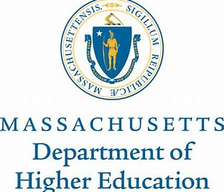
MEMORANDUM
To: Karen Hynick, North Shore Community College
Jason Colombino, Danvers High School

From: Kristin Hunt, MA Early College Director
Date: 20 December 2019
Re: Massachusetts Early College Designation Part A Application

__________________________________________________________________________
Thank you for submitting an application for Part A of the Massachusetts Early College Designation process. While there are several key components of a Designated program evident in your application, we have identified issues that would benefit from additional consideration and technical assistance. Therefore, we are withholding an invitation to advance to Part B of the Designation. Rather, we would like to support your work to further develop your Part A application.

Areas of concern to address are:
- Hybrid model of course delivery
  - Please note: current proposals with a hybrid model are on hold until guidance can be provided
- Recruiting
- Eligibility requirements

Our Early College team will follow up with you in January about next steps and resources we can provide to assist you in continuing the development of your application.

While it is still possible that your program will receive a designation from the state, please be advised that this would occur on a different timeline than the programs that are immediately moving forward to Part B. This means that while additional planning funding may become available, your program will not be eligible for implementation funding for Fall 2020.

We are grateful for your work to develop and expand the Designated Early College model and look forward to supporting your efforts to promote the postsecondary participation and success of our students.

Sincerely,

Kristin Hunt
MA Early College Director

